OOPS LAB

Experiment -6

NAME- ANMOL YADAV SAP ID- 500083814 ROLLNO- R214220178

**Question: 1**

Write a Java program to implement the concept of importing classes from user defined package and created packages.

**Code:**

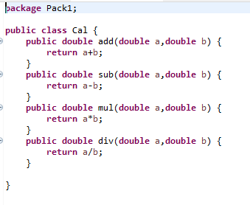

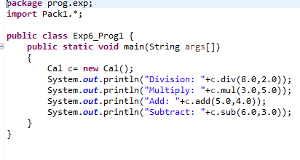

**Output:**

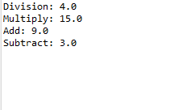

**Question: 2**

Write a program to make a package Balance. This has an Account class with Display_Balance method. Import Balance package in another program to access Display_Balance method of Account class.

**Code:**

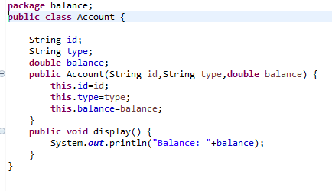

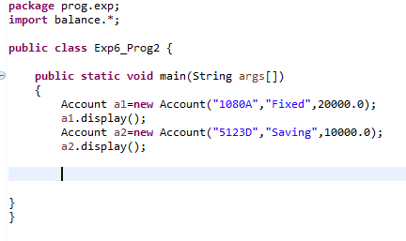

**Output:-**

